Hypervolume

Definition
# Source: AI Source: Provided by: [Data Path: Persons Table -> ID Column: 1, Name_En Column: Motasem Essam] -> From: [ChatGPT] on [7/17/2026]
Hypervolume is the measure of the size of a geometric object in four or more dimensions. It is the higher-dimensional extension of familiar geometric measures:
- Length in one dimension (1D)
- Area in two dimensions (2D)
- Volume in three dimensions (3D)
Hypervolume is used to measure the extent of objects in n-dimensional space, where $n≥4$.

Characteristics
# Source: AI Source: Provided by: [Data Path: Persons Table -> ID Column: 1, Name_En Column: Motasem Essam] -> From: [ChatGPT] on [7/17/2026]
Hypervolume:
- Measures the size of an object in four or more dimensions.
- Generalizes the concept of volume.
- Is expressed in units raised to the power of the number of dimensions.
- Is primarily a mathematical concept.
- Cannot be directly visualized because humans perceive only three spatial dimensions.

Dimensional Progression
# Source: AI Source: Provided by: [Data Path: Persons Table -> ID Column: 1, Name_En Column: Motasem Essam] -> From: [ChatGPT] on [7/17/2026]
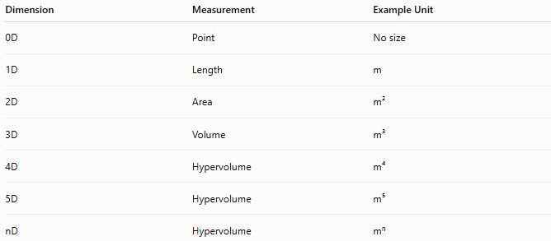
Dimension | Measurement | Example Unit
0D | Point | No size
1D | Length | m
2D | Area | m²
3D | Volume | m³
4D | Hypervolume | m⁴
5D | Hypervolume | m⁵
nD | Hypervolume | mⁿ

Illustration
# Source: AI Source: Provided by: [Data Path: Persons Table -> ID Column: 1, Name_En Column: Motasem Essam] -> From: [ChatGPT] on [7/17/2026]
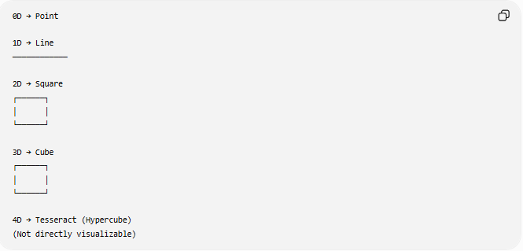
0D → Point

1D → Line
────────────

2D → Square
┌──────┐
│ │
└──────┘

3D → Cube
┌──────┐
│ │
└──────┘

4D → Tesseract (Hypercube)
(Not directly visualizable)

Mathematical Representation
# Source: AI Source: Provided by: [Data Path: Persons Table -> ID Column: 1, Name_En Column: Motasem Essam] -> From: [ChatGPT] on [7/17/2026]
Hypervolume is commonly represented by:
$$V_{n}$$
where:
- $V_{n}$= Hypervolume in $n$dimensions

Hypercube Hypervolume
# Source: AI Source: Provided by: [Data Path: Persons Table -> ID Column: 1, Name_En Column: Motasem Essam] -> From: [ChatGPT] on [7/17/2026]
For an $n$-dimensional hypercube with side length $s$:
$$V_{n}=s^{n}$$
Examples:
Square (2D)
$$A=s^{2}$$

Cube (3D)
$$V=s^{3}$$

Tesseract (4D)
$$V_{4}=s^{4}$$

Example
# Source: AI Source: Provided by: [Data Path: Persons Table -> ID Column: 1, Name_En Column: Motasem Essam] -> From: [ChatGPT] on [7/17/2026]
A four-dimensional hypercube with side length:
$$s=2\text{ m}$$
has hypervolume:
$$V_{4}=2^{4}=16{\text{ m}}^{4}$$

Units
# Source: AI Source: Provided by: [Data Path: Persons Table -> ID Column: 1, Name_En Column: Motasem Essam] -> From: [ChatGPT] on [7/17/2026]
Hypervolume is measured using units raised to the number of dimensions.
Examples:
- m⁴
- cm⁴
- ft⁴
- km⁴

Applications
# Source: AI Source: Provided by: [Data Path: Persons Table -> ID Column: 1, Name_En Column: Motasem Essam] -> From: [ChatGPT] on [7/17/2026]
Hypervolume is used in:
- Higher-Dimensional Geometry
- Linear Algebra
- Multivariable Calculus
- Topology
- Differential Geometry
- Data Science
- Machine Learning
- Optimization
- Computational Geometry
- Theoretical Physics

Advantages
# Source: AI Source: Provided by: [Data Path: Persons Table -> ID Column: 1, Name_En Column: Motasem Essam] -> From: [ChatGPT] on [7/17/2026]
Studying hypervolume helps to:
- Generalize geometric measurement.
- Analyze multidimensional spaces.
- Support mathematical modeling.
- Solve optimization problems.
- Study higher-dimensional objects.

Limitations
# Source: AI Source: Provided by: [Data Path: Persons Table -> ID Column: 1, Name_En Column: Motasem Essam] -> From: [ChatGPT] on [7/17/2026]
Hypervolume:
- Cannot be directly visualized beyond three dimensions.
- Requires advanced mathematical methods.
- Is mainly theoretical in many applications.

Comparison with Other Measurements
# Source: AI Source: Provided by: [Data Path: Persons Table -> ID Column: 1, Name_En Column: Motasem Essam] -> From: [ChatGPT] on [7/17/2026]
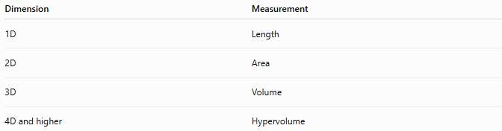
Dimension | Measurement
1D | Length
2D | Area
3D | Volume
4D and higher | Hypervolume

Key Points
# Source: AI Source: Provided by: [Data Path: Persons Table -> ID Column: 1, Name_En Column: Motasem Essam] -> From: [ChatGPT] on [7/17/2026]
- Hypervolume measures the size of objects in four or more dimensions.
- It generalizes volume to higher-dimensional spaces.
- An $n$-dimensional hypercube has hypervolume:
$$V_{n}=s^{n}$$
- Hypervolume is measured in units such as:
$$m^{4}, m^{5}, …, m^{n}$$
- It is widely used in advanced mathematics, theoretical physics, computational geometry, optimization, and machine learning.

Conclusion
# Source: AI Source: Provided by: [Data Path: Persons Table -> ID Column: 1, Name_En Column: Motasem Essam] -> From: [ChatGPT] on [7/17/2026]
Hypervolume is the higher-dimensional extension of volume, used to measure the size of objects in spaces with four or more dimensions. It generalizes the progression from length (1D) to area (2D) and volume (3D), providing a mathematical framework for analyzing multidimensional objects. Although hypervolume cannot be directly visualized beyond three dimensions, it is fundamental in higher-dimensional geometry, linear algebra, multivariable calculus, topology, optimization, theoretical physics, computational geometry, data science, and machine learning, where multidimensional spaces are routinely studied and analyzed.

